**8sj31j oscilloscope clock debugging instructions**

Key inspection items before power on

1. Whether the welding position of the device is consistent with the list

2. Whether there are missing or continuous welding spots

3. Whether the polarity direction of devices with polarity and direction is correct, including diode, electrolytic capacitor, solid-state capacitor, triode and three terminal voltage regulator

4. Whether the installation direction of all chips is correct

5. If possible, measure each power supply for short circuit to ground

6. Jumper cap shall be used for short circuit of J7 1 and 2 pins of control board (two pins close to XH socket direction). Whether jumper cap has been installed

Key inspection items after power on

1. The power supply voltage is 12V. Before the oscilloscope filament gets hot, the current of the whole machine will be relatively large, and then it will slowly drop down. If 8sj31j oscilloscope is used, the current will be stable at about 0.85a

2. Whether the red LED on the control board and neon bubble on the drive board are on

3. Whether the voltage of each power supply to the ground is normal: the output of two 78l05 is about 5V, and the output of 79l05 is about - 5V,

The voltage of 300V power supply is about 305V. In general, if the 300V power supply is normal and the high voltage of the oscilloscope tube is normal without special inspection

Adjustment method

Note: since the potentiometer on the drive board is connected to the high-voltage circuit of the oscilloscope tube, when adjusting the potentiometer on the drive board, be sure to use a screwdriver with an insulating handle and hold the insulating handle for adjustment. Avoid touching the metal part of the screwdriver, the high-voltage part of the drive plate, or any part of the potentiometer with both hands.

Adjustment of drive plate

1、 If the board is not abnormal after power on, wait for about half a minute for the cathode of the oscilloscope tube to heat up, and then rotate the brightness control potentiometer R21 (INTEN) on the drive board clockwise, the display should appear on the screen. If the screen does not light up, check whether J7 on the control board has installed the jumper cap. If it still doesn't light, check the welding and the connection between the boards again, or contact the owner.

2. Adjust R21 to make the brightness of oscilloscope moderate, not too bright or too dark

3. Adjust R20 (focus) and R46 (astig, auxiliary focus) to make the line display on the screen the thinnest and clearest. If the focus is not good, adjust R21 to slightly reduce the brightness.

Adjustment of control panel

1. Adjust R44 (H size, horizontal size), r48 (H POS, horizontal position), R51 (V size, vertical size), R54 (V POS, vertical position) to move the graph to the middle of the screen and see the display completely

2. Press the rotation axis of the rotary encoder, the menu will be displayed on the screen, rotate and select adjust display, press the rotation axis to enter the menu, rotate and select to the following figureCalibrate the graph (because the adjustment has not been completed, the displayed graph will have some deformation)

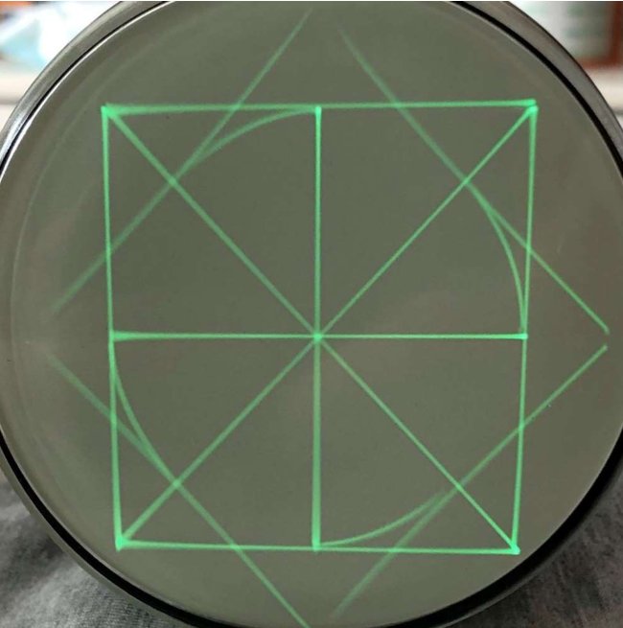

3. Adjust the other potentiometers on the control board, and adjust this calibration pattern to the pattern shown in the figure above. Adjust the

The figure will change accordingly. With reference to this figure, you can test the function of each potentiometer (adjusting the potentiometer will not damage the circuit). In this step, you may need to adjust the four potentiometers in step 1 in combination, so that the size and position of the figure are finally as shown in the figure above. If the potentiometer cannot be adjusted to the effect shown in the figure above, you can replace the device according to the notes in the list, or contact the owner

4. You can rotate the knob to select different graphics, adjust the potentiometer on the drive board, and further adjust the focus of the oscilloscope to make the graphics and text display clearer. Because 8sj31j is a relatively old electronic device, the focus on the edge may not be as good as the middle part, as long as the difference in definition is not particularly large, it is generally a normal phenomenon

5. Press the rotary axis of the rotary encoder to exit the calibration interface and return to the menu. Turn the knob to select exit. Press the rotary axis to return to the clock interface. At this time, the display of numbers and letters will be normal without distortion

6. If you want the pointer clock to fill the screen, you can adjust R44, r48, R51, R54 again to the effect you like